**Campaign Analytics**

**Purpose of this document**

This document explains the analytics dashboard available for the campaigns that are in ‘Sent’ status. A campaign can be defined as a series of marketing links associated to a property(s) in order to promote them to the end user(s). A campaign can be sent to the end users through emails that are acquired in the process of promotions.

**Overview**

Once a campaign is sent to the end users, the analytics related to it are calculated in order to understand the response from the end users. The information collected post sending a campaign is – Open Rate; Click Rate; Sent; Bounced; Delivered; Most Popular Links; Number of Clicks etc.

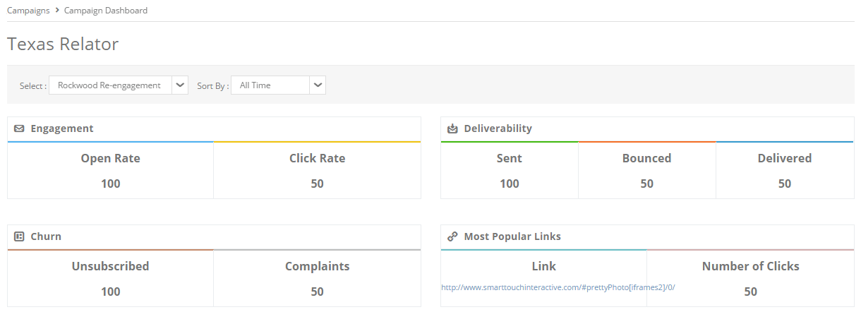

The snapshot below explains the analytics that are calculated and displayed for a campaign that is sent. This dashboard is only available for sent campaigns. The following data is collected from this dashboard. The user shall land to this view by selecting a campaign in ‘Sent’ status. These analytics are unique per campaign.

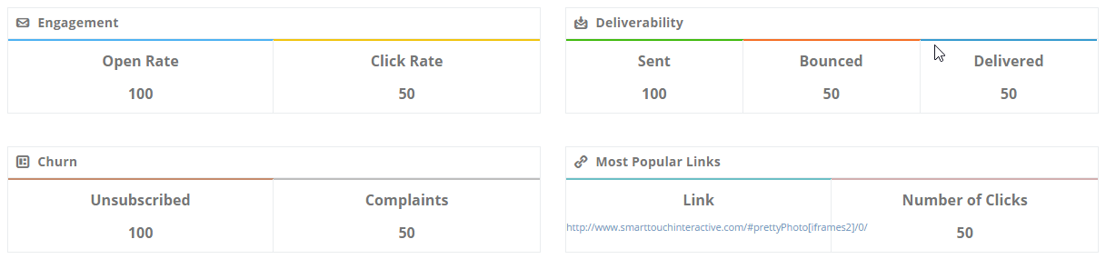

* **Open Rate:** This is the number of recipients who open your email to read it. Due to the way open rates are tracked and the rise of image-blocking software, this number will never be accurate, but can still be useful.
* **Click Rate:** This is the number of times any recipient clicks on any track able link within the email. Ideally, each link should be counted only once, even if it is clicked on multiple times.
* **Sent:** This is the number of outbound emails sent as part of a particular mailing.
* **Bounced:** This dashboard view specifies the number of undelivered emails.
* **Delivered:**This is the number of sent emails actually delivered to recipients’ inboxes.
* **Unsubscribed:** This is the number of individuals who unsubscribe from your list in response to each mailing sent.
* **Complaints:** This number specifies the number of emails that are reported as spam based on the complaints received by the internet service providers from the recipients.
* **Link:** This section shall display the five most popular links out of all those associated to the campaign. The popularity selection is based on the number of clicks.
* **Number of Clicks:** This number specifies the number of unique clicks for the link that makes it popular among all.

[This section is drafted as per the current functionality that is been understood. Will update this section lately post implementation of Marketing Automation]

The fields below are functional when the campaign is associated with the ‘Marketing Automation’ module. The following is the functionality related to these fields:



Select – This field shall populate the automations that are associated to this campaign. Hence the campaign analytics shall appear with respect to the automation name that is selected here.

Sort By – This dropdown shall list the duration – Last 7 days; Last 30 days; Last 60 days; Last 90 days; Custom [shall populate the date pickers for selecting a duration]. The count in the analytics dashboard shall differ as per the duration selection.

Apply – Is to trigger the action as per the values that are selected in the above fields.

Download CSV – Is an option available to the user to download the analytics in the CSV format.

**General Assumptions and Use Cases**

1. The analytics dashboard shall be available only for campaigns that are in ‘Sent’ status.
2. The calculation of the figures in the analytics section depend upon the email configuration in the account settings window.
3. The click rate shall be considered even for broken links as well.
4. The broken links shall redirect to the homepage or a message – ‘No options are currently available’.
5. The email redirected to the spam folder of an end user(s) id is also considered as ‘Delivered’.
6. The emails that are not delivered to the end user(s) on account of invalid ids or ids that are not in use anymore, are counted under bounced.